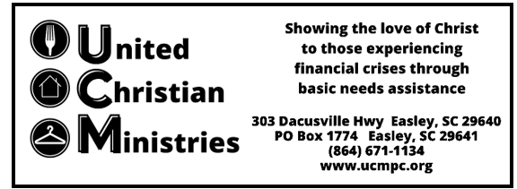

2025 Pantry Needs

Canned Beans (low sodium preferred)

Canned Soup (low sodium and low-fat preferred)

Canned Fish (in water) (tuna, salmon, etc.)

Canned Fruit (in water or 100% fruit juice/no sugar added/no high fructose syrup preferred) (cocktail, peaches, pears, etc.)

Canned Meals (beef stew, ravioli, etc.)

Canned Meats (in water or low sodium preferred) (chicken, ham, etc.)

Canned Vegetables (less/low sodium preferred) (potatoes, peas, corn, green beans, tomatoes, carrots etc.)

Cereal (whole grain, low sugar preferred)

Crackers (saltine, graham, etc.)

Dried Beans (1-2 pounds)

Grits

Jelly

Jiffy Muffin Mix

Juice (no sugar added preferred)

Macaroni & Cheese

Oatmeal

Peanut Butter (Natural preferred)

Powdered or Shelf Stable Milk

Rice (1-2 pounds) (brown, white, wild)

Spaghetti Noodles (1-2 pounds) (whole wheat preferred)

Spaghetti Sauce (canned or plastic jars)

Hygiene:

Bar Soap

Toilet Paper

Laundry Detergent (pods or powder)

**Service Hours: M,W,F 9:00 – 11:45am (food) 9:00-11:00am (financial)**

**Staff Hours: M-F 8:30am-4:30pm**

Donations may be dropped off at UCM during our service hours at the double doors facing Henry Street. If you are unable to come during those times, please email ucmpc2018@gmail.com or call (864) 671-1134 ext 1028 to schedule a delivery time during staff hours. Thanks for your support.